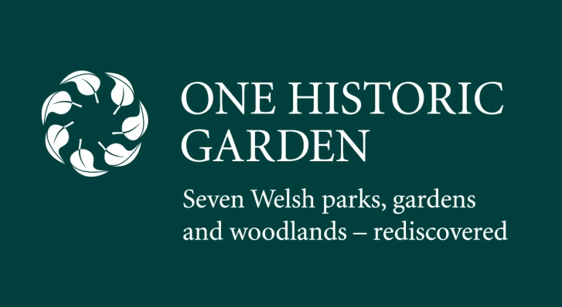
Date: March 2013

PRESS RELEASE
Seven very special gardens in South and West Wales are enjoying the benefits of
being re-invigorated and revitalised
In our busy lives it is more important than ever to re-connect with nature. In Wales, seven historic gardens, have been give a great regeneration boost. Funded by the European Regional Development Fund through Visit Wales and the Welsh Government, One Historic Garden invites you to step into history, and explore revitalised gardens and landscapes, delve into the wilderness and have close encounters with native wildlife. Seven gardens – so much to see.
How about watching how an historic hidden garden terrace - unseen for 150 years - is slowly being rediscovered; stepping into a restored walled kitchen garden - unused for over 60 years, swinging over a rushing stream, meandering through a wildflower meadow or discovering where Dylan Thomas enjoyed youthful inspiration?
If anything unites the seven very different gardens at Bryngarw Country Park, Margam Country Park, Penllergare Valley Woods, Cwmdonkin Park, Aberglasney Gardens, Scolton Manor, and Colby Woodland Garden it is that each has a story to tell. A programme of regeneration in different ways is bringing each landscape to the peak of condition.
Dylan Thomas spent his childhood playing in Cwmdonkin Park calling it “a world within a world”. As the centenary of his birth approaches in 2014 the park is restoring features that inspired Wales’ favourite modern poet to write many of his poems.
At Bryngarw Country Park the elegant 18th-century country house nestles in 113 acres of woods and fields. Now it is home to an amazing selection of wildlife from bats, birds and butterflies to the shyer polecat, nuthatch and dipper. And its highly skilled rangers offer fascinating bush craft courses such as foraging and den building.
Margam Country Park may now host film crews from around the world but its fairytale castellated mansion, and 1,000 acres of land tell an 800 year story through monastic ruins, to a restored exotic orangery – the longest in Britain - and citrus house, with an ancient walled kitchen garden on its way to being restored.
Penllergare Valley Woods are undergoing one of the more drastic transformations. Left in disarray and disrepair for some decades a team of dedicated volunteers are painstakingly uncovering and restoring the 250 acre “edge of wilderness” valley and its amazing terraces and waterfalls built by early photographer John Dillwyn Llewellyn.
Aberglasney Gardens in the Twig Valley in Carmarthenshire has been home to a monastery for centuries. The restoration programme here brings back to life the historic features of the Grade II listed house. Don’t miss the unique cloister garden, sunken garden, pool garden, yew tunnel, woodland garden, walled garden and indoor semi- tropical ‘ninfarium’ in the ruins.
Scolton Manor in Pembrokeshire persuades you to step back in time to the life of a Victorian country squire. The large walled garden is undergoing extensive restoration with an exotic ‘hot’ pineapple house already up and working. This June sees the opening of the ‘Honey Kitchen’ where honey from the estate is processed and bottled.
Colby Woodland Garden is a haven for woodland play and encourages families with children to come and enjoy the natural attractions. There are no `Keep of the Grass’ signs here, just rope swings and stepping stones across the streams. Historically, Colby is famed for the anthracite mined in its small woodland pits, which was a favourite of Queen Victoria for its ‘smokefree’ quality.
Notes to Editors:
1. One Historic Garden is part-funded through EU’s Convergence European Regional Development Fund through Visit Wales and Welsh Government.
2. Website launches on 25th March 2013
3. Press trips available
4. Large selection of images available
Contact:
Colette Walker, Blue Sail Colette.walker@bluesail.com 07988 447573
Laura Brown, Blue Sail Laura.brown@bluesail.com 07739 321279
www.onehistorigarden.co.uk

